|  |
| --- |
|  |

**WebDSS Tutorial and User Guide**

User guide for the Graphical User Interface component of the Bushfire Evacuation Model Decision Support System (DSS) Web application

Leorey Marquez, Pawan Deegoda Gamage, Dhirendra Singh, Vincent Lemiale

EPXXXXXXX  
September 2021

Copyright

© Commonwealth Scientific and Industrial Research Organisation 2020. To the extent permitted by law, all rights are reserved and no part of this publication covered by copyright may be reproduced or copied in any form or by any means except with the written permission of CSIRO.

Important disclaimer

CSIRO advises that the information contained in this publication comprises general statements based on scientific research. The reader is advised and needs to be aware that such information may be incomplete or unable to be used in any specific situation. No reliance or actions must therefore be made on that information without seeking prior expert professional, scientific and technical advice. To the extent permitted by law, CSIRO (including its employees and consultants) excludes all liability to any person for any consequences, including but not limited to all losses, damages, costs, expenses and any other compensation, arising directly or indirectly from using this publication (in part or in whole) and any information or material contained in it.

**Table of Contents**

1 Introduction 4

1.1 Service Objectives 4

1.2 Application Structure 4

1.3 Simulation Overview 4

1.3.1 Simulation Terminology 4

1.3.2 Components of a Scenario Simulation 4

1.4 User Guide Organisation 5

2 Installation 7

2.1 System Requirements 7

3 Tutorial 8

3.1 Fire scenarios 8

3.2 Running the WebDSS application 9

3.3 Creating a new job 10

3.4 Defining a new scenario 11

3.5 Running a simulation 12

3.6 Loading a previously saved job file 14

3.7 Comparing time of fire impact 15

3.8 Viewing maps of the population and network metrics 16

3.9 Changing the layer settings 17

3.10 Viewing charts of the metric outputs 18

3.11 Exporting data 20

4 References 22

5 Appendix A: Sample Job File 23

6 Appendix B: Viewer Controls 24

7 Appendix C: Menus and Dialogs 27

7.1 Main menu 27

7.2 Job menu 27

7.3 Logs menu 29

8 Appendix D: Scenario Settings 31

9 Appendix E: Map and Layer Settings 34

9.1 Colour scales 35

9.2 Map styles 37

10 Appendix G: Outputs Panel 40

11 Appendix F: Output Metrics 43

# Introduction

XXXXXGet background for WEBDSS

## Service Objectives

XXXXX Get Questions for WEBDSS

## Application Structure

XXXXX Get APP Structure for WEBDSS

## Simulation Overview

XXXXX Get simulation flowchart for WEBDSS

XXXXX Discuss simulation procedure

### Simulation Terminology

XXXX To clarify the nature of simulation runs that are performed or analysed by WebDSS, the following terminology have been adopted:

* **Simulation:** A generic name given to any number of MATSim-based simulation runs performed by the WebDSS.
* **Scenario:** The set of input files that define the road network, population, fire event and evacuation plan to be used as inputs to an evacuation simulation.
* **Scenario Simulation:** The application of the MATSim-based JAR on a defined scenario to perform an evacuation simulation and produce performance outputs and metrics.
* **Job:** The simulation package consisting of the input scenario files and the simulation outputs.

### Components of a Scenario Simulation

XXXXXX Discuss inputs

* **Regional road network:** XXXXXXXXX.
* **Regional population:** XXXXX. Population of vehicles
* **Fire event:** XXXXX.
* **Fire ignition time:** XXXXX
* **(optional) Evacuation plan:** XXXXX.



Figure 1. Components of a scenario simulation in FEM2.1 (XXXX Replace with WebDSS chart)

XXXX The following sequence describes the tasks involved in performing a fire evacuation simulation in WebDSS:

1. XXXX The scenario input files along with additional parameter settings (such as the **Fire ignition time**) constitute a simulation job and so WebDSS creates a job file (in XML format) from these settings. Please refer to **5 Appendix A: Sample Job** File for more details on the contents of a WebDSS Job file.
2. XXXX When a run request is made, WebDSS creates a corresponding EES configuration file (**EES config file**) for the job file which is needed by the MATSim JAR to run the evacuation simulation.
3. XXXX MATSim then performs a simulation run using the **EES config** file.
4. XXXX When the run completes, MATSim stores the simulation outputs as part of the Job package.

## User Guide Organisation

This document is the Tutorial and User Guide for WebDSS. The succeeding chapters are organised as follows:

* **2 Installation**  discusses the requirements for installing and running the WebDSS application.
* **3 Tutorial** presents a tutorial on running a fire evacuation simulation using the sample data set included in the application.
* **4 References**  presents the references used in this document.

* **5 Appendix A: Sample Job File** describes the contents of a WebDSS simulation job file.
* **6 Appendix B: Viewer Controls** describes the functions of the controls displayed in the WebDSS main window.
* **7 Appendix C: Menus and Dialogs** describes the contents of the menus and dialogs presented by WebDSS.
* **8 Appendix D: Scenario Settings** describes the contents of the **Scenario Settings** panel.
* **9 Appendix E: Map and Layer Settings** describes the contents of the **Map & Layer Settings** panel.
* **10 Appendix G: Outputs Panel** describes the contents of the **Outputs** panel.
* **11 Appendix F: Output Metrics** describes the values collected for the metrics presented in the **Outputs** panel.

The discussions in the Tutorial and User Guide for WebDSS will regularly refer to tables, figures and appendix items for additional information. These references are live hyperlinks which can be used to jump directly to the location of the information. Please use the following keys to navigate these links:

* Press **Ctrl-Click** on the link to jump to the location of the information.
* Press **Alt-LeftArrow** to jump back to the previous location.

# Installation

XXXXX Discuss system requirements for WEBDSS

## System Requirements

XXXX The following software and hardware requirements need to be met for WebDSS to work:

**Software Requirements**

1. XXXX Microsoft Windows – WebDSS will run in a Windows environment, and has been developed, and tested on 64-bit Windows 10. (What about IOS, Linux?)
2. Discuss the suitability of the different browsers (Chrome, Edge, Firefox, Safari, etc)

**Hardware Requirements**

1. Internet connection
2. Discuss guidelines on what devices can be used (laptops, tablets, mobile phones, etc)

# Tutorial

The following sections illustrate the steps needed to run a simulation of an evacuation from a bushfire event using the sample data provided in WebDSS.

## Fire scenarios

The tutorial will display the results of the simulation of evacuations in the Surf Coast Shire triggered by two fire events generated using the Phoenix RapidFire bushfire simulator.

The first fire event is loaded using the file **Aireysinlet_evac_test** and starts from a point with longitude 143.986 and latitude -38.382. The fire burns for XXXX hours and covers an area of XXXX sq. kms, as shown in Figure 2.



Figure . Fire event **Aireysinlet_evac_test**

The second fire event is loaded using the file **DSSrun2_grid** and starts from a point with coordinates longitude 143.881 and latitude -38.451. The fire burns for XXXX hours and covers an area of XXXX sq. kms, as shown in Figure 3.



Figure . Fire event **DSSrun2_grid**

WebDSS will be used to run a simulation of the evacuation of the selected population in the SurfCoast Shire region using the road network in the SurfCoast Shire and a chosen ignition time for the fire event. The first simulation will use the fire event **Aireysinlet_evac_test.**

## Running the WebDSS application

To run WebDSS:

1. Make sure all the preliminary requirements for running the DSS have been completed. Please refer to **2 Installation** for a discussion of the preliminary requirements for running WebDSS.
2. In your browser, enter the URL **dss.indraweb.io**. The login window for WebDSS will appear as shown in Figure 4.
3. Enter your assigned username and password. Then click on the **Login** button. The Welcome window for WebDSS will appear as shown in Figure 5.
4. Read the disclaimer on the Welcome window. Then click on the **Agree** button.

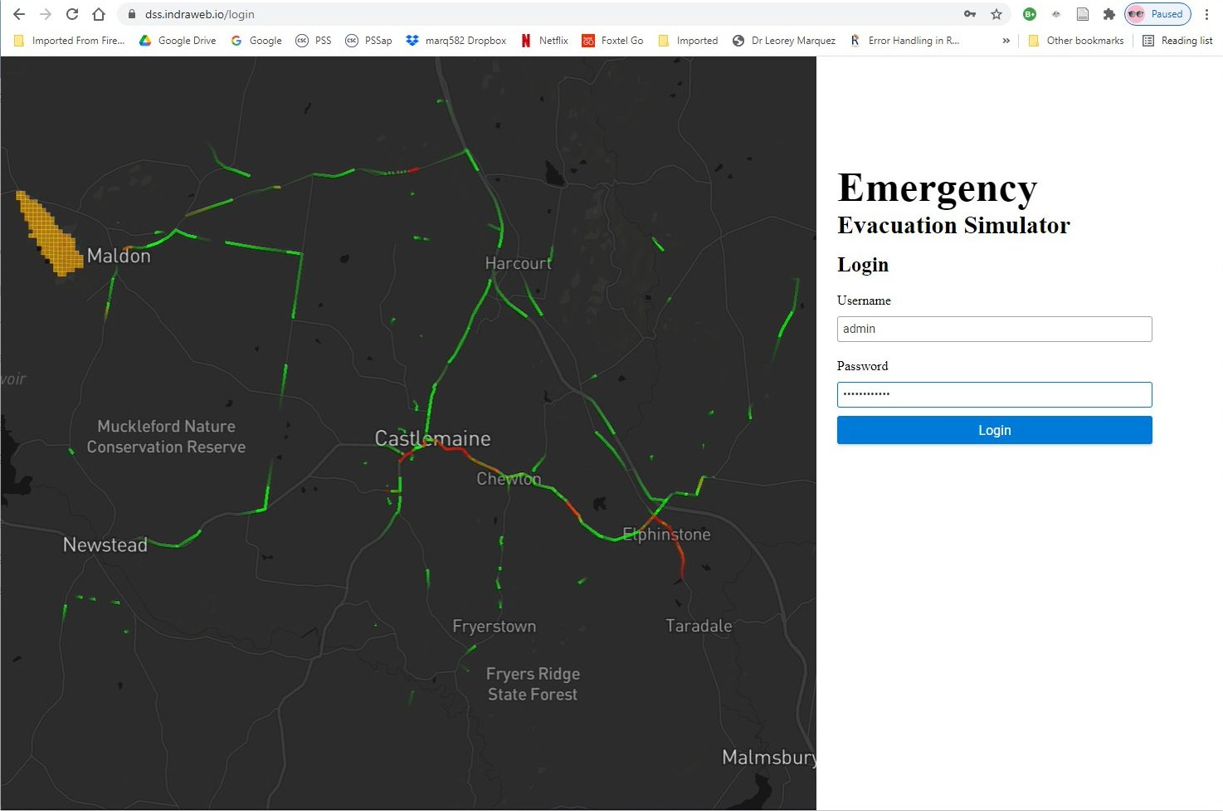

Figure . Login window for WebDSS

If the opening of WebDSS is successful, the main window of WebDSS will be displayed as shown in Figure 6. Note the location of the different viewer controls. The main window will display the maps associated with the simulation modelling so it will also be referred to as the **Map Viewer**.

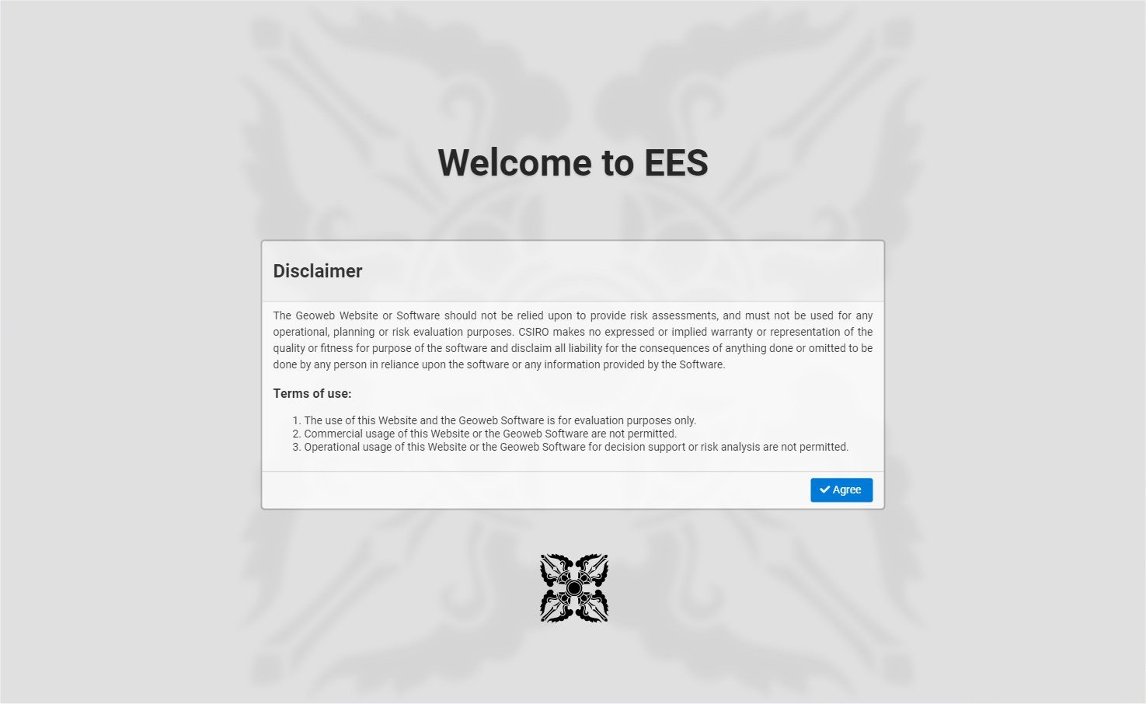

Figure . Welcome window for WebDSS

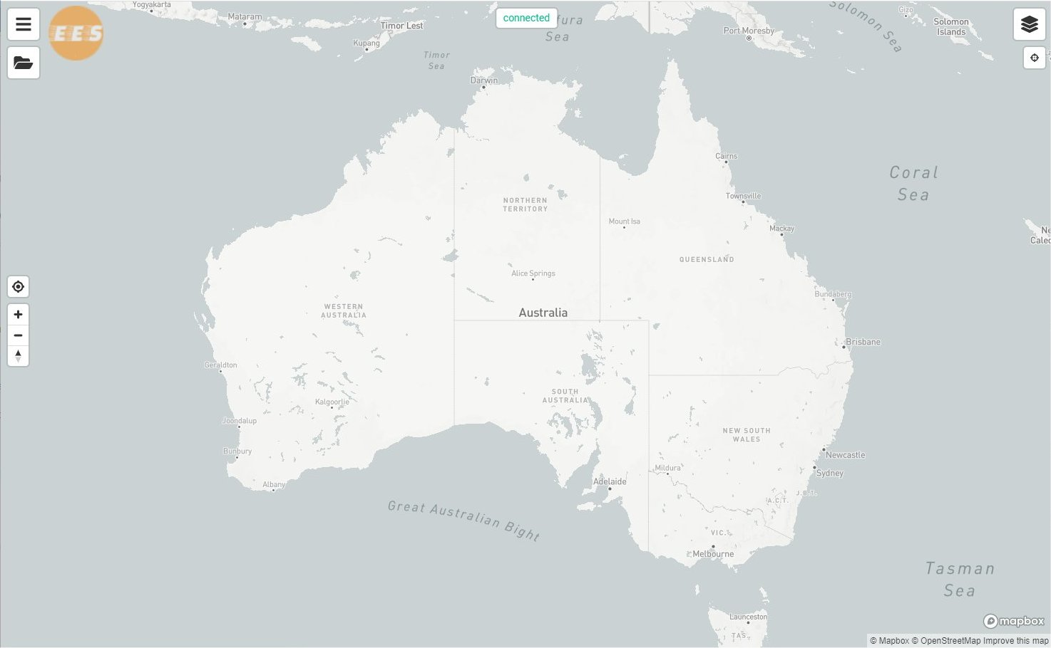

Figure 6. Main window of WebDSS showing the viewer controls.

Please refer to **6 Appendix B: Viewer Controls** for a description of the controls in the Map Viewer.

## Creating a new job

WebDSS allows users to create new jobs from sample input files provided with the application.

To create a new job called **myJob1**:

1. Click on the ***Show Menu*** button in the Map Viewer. This will open the Main menu as shown in Figure 21. Please refer to Table 2 for a description of the options in the Main menu.
2. Click on the ***Job*** option to open the Job menu as shown in Figure 22. Please refer to Table 3 for a description of the options in the Job menu.
3. Click on the ***New*** option to open the **New Job** dialog, as shown in Figure 23.
4. Enter **myJob1** in the ***Name*** edit box. (If the job name has already been used, enter a different job name. Note that only alphanumeric characters are allowed in the job name.)
5. Click on the ***Create Job*** button. The WebDSS will display the message ”**Job myJob1 is loaded**”.

WebDSS has now created a Job **myJob1** in the WebDSS server. However, **myJob1** has no defined scenario so running this job at this point will produce an error. We need to define a scenario for **myJob1**.

## Defining a new scenario

To define a scenario for **myJob1**:

1. Click on the **Edit Layers**button in the Map Viewer . This will open the **Scenario** **Settings** panel as shown in Figure 7. For more details on the controls used in the **Scenario Settings** panel, please refer to **8 Appendix D: Scenario Settings** .
2. Click on the option **Surf Coast Shire Roads** displayed within the **Select a Region** list box. This will open the remainder of the **Scenario Settings** panel.
3. In the **Fire** dropdown box, click the down arrow and select the option **AireysInlet_evac_test**.
4. In the **Fire ignition time** edit box, enter **11:00** or use the up/down arrows in the box.
5. In the **Population** dropdown box, click the down arrow and select the option **Anglesea_Sample_20_Persons*.*** This is a population file giving the attributes of 20 people. The size of the population, as well as the size of the road network, will seriously affect the length of time needed to complete a simulation run. The larger the population or road network, the more time will be required to complete a simulation run. Our choice of a population of 20 will result in a short time needed to perform the simulation run.



Figure . List of regions available in Scenario Settings panel

These settings are sufficient to define the new scenario. We can add (optional) evacuation messages to be issued to selected evacuation zones at 12noon.

1. In the map, zoom in on the town of Anglesea. Move the time slider left or right to see the changing coverage of the fire and the changing location and activities of the population at different times of the day. Set the slider to the time of **12:00** to show the beginning of the fire event.
2. Click on the **Show Evacuation Zones** button to highlight the evacuation zones. The evacuation zones will be shaded in lavender.
3. Click on the **Multiple Evacuation Messages** button to turn on zone selection mode. The instruction **Click again after selection>** will appear to the left of the button.
4. Click on one or more of the evacuation zones surrounding the fire, as shown in Figure 8. The selected zones will be shaded in dark lavender.
5. Click on the **Multiple Evacuation Messages** button a second time. This will open the **Evacuation Messages** dialog, as shown in Figure 28. The messaged zones box will contain the names of the zones selected for this messaging instruction. Please refer to Table 8 for the description of the controls in the **Evacuation Messages** dialog.
6. In the messaging **Time** edit box, enter **12:00** or use the up/down arrows in the box.
7. In the **Message Type** dropdown box, select **EVACUATE_NOW**.
8. In the optional comments text box, enter **Evacuate zones near fire at 1200**.
9. Click on the **Add** button. The entry **1200: EVACUATE_NOW** will now appear in the Evacuation Plan list box. Selecting this entry in the list box will highlight the zones selected to receive this message.

These settings will complete the specifications for the new scenario. We are now ready to run the evacuation simulation.



Figure . Evacuation zones selected for messaging using the **Multiple Evacuation Messages** button

## Running a simulation

To run the simulation for the scenario in **myJob1**, click on the ***Run Simulation*** button in the Map Viewer.

Another way of running the simulation is to do the following:

1. Click on the ***Show Menu*** button in the Map Viewer. This will open the Main menu as shown in Figure 21. Please refer to Table 2 for a description of the options in the Main menu.
2. Click on the ***Job*** option to open the Job menu as shown in Figure 22. Please refer to Table 3 for a description of the options in the Job menu.
3. Click on the ***Load*** option to open the **Load Job** dialog as shown in Figure 24. Please refer to Table 4 for a description of the controls in the **Load Job** dialog.

The **Load Job** dialog will list the jobs in the WebDSS server that are available for loading or running. Note that **myJob1** is listed along with a set of controls. The functions of the controls in the dialog are described in Table 4. The **Run Simulation** icon opposite **myJob1** indicates that **myJob1** has a pending simulation run waiting to be performed.

1. Click on the **Run Simulation** button corresponding to **myJob1**. WebDSS will start running the simulation. A progress bar will be displayed on the screen, as shown in Figure 9.
2. When the progress bar reaches 100% or when the progress bar disappears, the simulation run is complete.



Figure . Progress bar displayed when running the simulation for **myJob1**



Figure . Animation bar with simulation of vehicle movement for **myJob1**

1. At the conclusion of the simulation run, an animation bar will be displayed at the bottom of the Map Viewer, as shown in Figure 10. The initial time in the simulation bar indicates the time when the first vehicle in the population will be moving.
2. Zoom in on Airey’s Inlet in the map and click the play button on the animation bar. The map will show the movement of vehicles along the road network over time, as shown in Figure 10. Use the up/down arrows in the animation bar to increase or decrease the animation speed.
3. Click on the **Outputs** button in the Map Viewer. This will remove the focus from the link outputs and load the values of the simulation metrics into the Map Viewer. Please refer to Table 1 for a description of the controls in the Map Viewer.
4. The Map Viewer will display three layers of metrics – **Area Burnt**, **Affected Zones**, and **Population in Zones**. We will now focus on the time of impact of the fire **Aireysinlet_evac_test** on the evacuation zones which is provided by the **Affected Zones** layer.
5. Turn off the display of the **Area Burnt** layer by clicking on its corresponding **Show/Hide** button. Please refer to **10 Appendix G: Outputs Panel**  for more details on the different controls in the **Outputs** panel.
6. Turn off the display of the **Population in Zones** layer by clicking on its corresponding **Show/Hide** button.
7. The Map Viewer will now show a thematic map of the evacuation zones based on the time of impact of the fire **Aireysinlet_evac_test**, as shown in Figure 11.
8. With the **Show Layer Values** button enabled, move the mouse over the town of Airey’s Inlet and the Map Viewer will display a balloon showing the time of impact of the fire **Aireysinlet_evac_test** on the town.

Since a small population of 20 was used in the scenario for **myJob1**, very few vehicles will be seen in the road network during the animation of the evacuation in **myJob1**. In order to see more vehicles on the roads, and produce meaningful analyses for the other metrics, we will have to look at a simulation that uses a much larger population.



Figure . Thematic map showing time of impact of fire **Aireysinlet_evac_test** on evacuation zones.

## Loading a previously saved job file

WebDSS provides two sample jobs that contain completed simulation runs using large populations.

* **SCS-Scenario-1** provides outputs from a simulation run using the **Surf Coast Shire** **Roads** network, the fire event file **DSSrun2_grid**, the population file **typical-midweek-day-in-jan-plans-epsg32754**, and no evacuation messages for all evacuation zones.
* **SCS-Scenario-2** provides outputs from a simulation run using the **Surf Coast Shire** **Roads** network, the fire event file **DSSrun2_grid**, the population file **Anglesea_Weekday_10_000_Persons**, and evacuation messages of **EVACUATE_NOW at 1200** for all evacuation zones.

We will now load the simulation outputs of **SCS-Scenario-2**.

1. Click on the **Show Menu** button in the Map Viewer. This will open the Main menu as shown in Figure 21. Please refer to Table 2 for a description of the options in the Main menu.
2. Click on the **Job** option to open the Job menu as shown in Figure 22. Please refer to Table 3 for a description of the options in the Job menu.
3. Click on the **Load** option to open the **Load Job** dialog as shown in Figure 24. Please refer to Table 4 for a description of the controls in the **Load Job** dialog.
4. Click on the option ***SCS-Scenario-2 emv2***.
5. Click on the **Load Job**button. A progress bar will be displayed on the screen, as shown in Figure 12.
6. When the progress bar disappears, zoom in on Airey’s Inlet in the map and click on the **Cars** button on the Map Viewer. This will display the animation bar at the bottom of the Map Viewer.
7. Click the play button on the animation bar. The map will show the movement of vehicles along the road network over time, as shown in Figure 13. Use the up/down arrows in the animation bar to increase or decrease the animation speed.



Figure . Progress bar displayed when loading **SCS-Scenario-2**



Figure . Animation bar with simulation of vehicle movement for **SCS-Scenario-2**

## Comparing time of fire impact

Aside from the volumes of vehicles on the road network, **SCS-Scenario-2** also contains the simulation outputs pertaining to the evacuation areas in the region.

To view the thematic map for the time of fire impact:

1. Click on the **Outputs** button in the Map Viewer. This will remove the focus from the link outputs and load the values of the simulation metrics into the Map Viewer. Please refer to Table 1 for a description of the controls in the Map Viewer.
2. Click on the **Edit Layers** button to open the **Outputs** panel in the Map Viewer. The Map Viewer will display three layers of metrics – **Area Burnt**, **Affected Zones**, and **Population in Zones**. We will now focus on the time of impact of the fire **DSSrun2_grid** on the evacuation zones which is provided by the **Affected Zones** layer.
3. Turn off the display of the **Area Burnt** layer by clicking on its corresponding **Show/Hide** button. Please refer to **10 Appendix G: Outputs Panel**  for more details on the different controls in the **Outputs** panel.
4. Turn off the display of the **Population in Zones** layer by clicking on its corresponding **Show/Hide** button.
5. The Map Viewer will now show a thematic map of the evacuation zones based on the time of impact of the fire **DSSrun2_grid**, as shown in Figure 14. Compare the thematic map in Figure 14 with the time of impact of fire **Aireysinlet_evac_test** shown in Figure 11.
6. With the **Show Layer Values** button enabled, move the mouse over the town of Airey’s Inlet and the Map Viewer will display a balloon showing the time of impact of the fire **DSSrun2_grid** on the town. Compare this time with the time of impact of fire **Aireysinlet_evac_test** on the town.



Figure . Thematic map showing time of impact of fire **DSSrun2_grid** on evacuation zones

## Viewing maps of the population and network metrics

Aside from the time of impact of the fire on the evacuation zones, **SCS-Scenario-2** also contains simulation outputs pertaining to populations in the evacuation areas in the region.

To view the output maps pertaining to population-related metrics:

1. Turn on the display of the **Area Burnt** layer by clicking on its corresponding **Show/Hide** button.
2. Turn on the display of the **Population in Zones** layer by clicking on its corresponding **Show/Hide** button.
3. Select the metric **Population in Zones**. The Outputs panel will expand to show more controls, as shown in Figure 15. Please refer to **10 Appendix G: Outputs Panel**  for more details on the different controls in the **Outputs** panel.
4. Use the time slider to move the Output **Time** to **14:00** (2 pm). The Map Viewer will display the simulation outputs produced at this time. Notice that the **Area Burnt** increases in size as the time slider moves to the right from the ignition time of 11:00 (11 am).
5. Click on the **Show Layer Values** button to enable the **Show Layer Values** tool**,** as shown in Figure 15. This tool displays the values of the displayed metrics for a given link or area just by pointing the mouse at the desired link or area.



Figure . Map Viewer with Outputs panel and Show Layer Values enabled.

The Map Viewer has the capability to display multiple layers of output values simultaneously. Figure 15 shows that three layers of metrics are currently on display – **Area Burnt**, **Affected Zones**, and **Population in Zones**. The legend windows show the colour scale used for each metric to identify the values associated with each area or link. Please refer to **11 Appendix F: Output Metrics** for more details on the different output metrics.

More map layers can be displayed by selecting the desired layer in the metric list and enabling display by clicking on the **Show/Hide** button beside the selected metric. The **Show/Hide** button is also used to remove a metric from the displayed layers in the Map Viewer.

1. Add the metric **Network Traffic** to the map display. Click the **Show/Hide** button beside the metric **Network Traffic** in the metric list to enable display of the layer. The legend window for **Network Traffic** will then appear in the Map Viewer.
2. Use the **Show Layer Values** tool to view the **Network Traffic** at various links in the road network.
3. Remove the metric **Network Traffic** from the map display by clicking on the **Show/Hide** button.

The metric layers are displayed according to a visibility hierarchy. Since the multiple layers are viewed from an imaginary point above the earth, layers that are positioned higher in the visibility hierarchy are displayed on top of layers that are placed lower in the hierarchy. The visibility hierarchy is indicated by the order in the metric list. Thus, a metric layer will be displayed on top of all displayed metric layers positioned below it in the metric list. This is why, in Figure 15, the layer for **Area Burnt** is displayed on top of the layer for **Affected Zones**, which in turn, is displayed on top of the layer for **Population in Zones**.

The position of a selected metric in the metric list (and consequently, in the visibility hierarchy) can be changed by using the visibility arrows to the right of the metric list in the **Outputs** panel. Please refer to **10 Appendix G: Outputs Panel**  for more details on the visibility controls in the **Outputs** panel.

1. Move the metric **Population in Zones** above **Area Burnt** in the metric list by selecting **Population in Zones** in the metric list and then clicking the **Move Visibility Up** arrow a sufficient number of times. The visibility of the **Area Burnt** layerin the Map Viewer will decrease as it now drawn under the layer for **Population in Zones.**

The outline of the layer **Area Burnt** is still visible in the Map Viewer since the layer above it, **Population in Zones**, is not totally opaque. **Opacity**, along with **Colour scale** and **Map Style**, are attributes of a map layer and can be modified by using the **Map & Layer Settings** panel.

## Changing the layer settings

Let us change some of the attributes of the layer **Population in Zones** .

1. Select the layer **Population in Zones** in the metric list.
2. Click on the **Map & Layer Settings** button in the **Outputs** panel. This will open the **Map & Layer Settings** panel at the bottom of the **Outputs** panel. Please refer to **9 Appendix E: Map and Layer Settings** for a description of the controls and options in the **Map & Layer Settings** panel.
3. Move the **Opacity** slider all the way to the right. This setting makes the layer **Population in Zones** total opaque (100% opacity). Note that the layer **Area Burnt** is no longer visible as it is now completely blocked by **Population in Zones**.
4. Move the **Opacity** slider all the way to the left to make the layer **Population in Zones** totally transparent (0% opacity). Note that the layer **Area Burnt** is now fully visible as **Population in Zones** becomes invisible.
5. Move the **Opacity** slider halfway to make the layer **Population in Zones** around 50% transparent (50% opacity).
6. Change the statistic used for mapping **Population in Zones** by selecting **Agents in Activities** in the dropdown box for **Colour by**.
7. Change the **Colour scale** used in the layer by selecting **interpolateYlGn** from the dropdown box.
8. Click on the **Reversed** button to enable **Reversed** colouring where green is assigned to the low values while yellow is assigned to the high values.
9. Change the **Map Style** used in the layer by selecting **Streets** from the dropdown box.

The Map Viewer should now appear as shown in Figure 16.

## Viewing charts of the metric outputs

Aside from thematic maps, the simulation outputs can also be viewed using charts. Please refer to **10 Appendix G: Outputs Panel**  for more details on the different controls in the **Outputs panel**.

1. Select the layer **Population in Zones** in the metric list.
2. Click on the **Show Chart** button in the **Outputs** panel. This will open a chart window containing a stack chart of the **Population in Zones** metric for all evacuation areas, with the selected statistic (**Agents in Activities**) on the Y-axis and **Time** (in hours) on the X-axis, as shown in Figure 17.
3. Move the mouse to point at one of the bars in the stack chart, say the bar at hour 7. A new window will appear containing a table of the evacuation areas, their associated colour and corresponding value, listed in the order of the selected stack bar, as shown in Figure 18.



Figure . Map display after changing the attributes of **Population in Zones**



Figure . Stack chart of **Population in Zones** for all evacuation areas over time



Figure . Stack chart with table of values bar at hour 7.

1. Move the mouse to click at one of the evacuation areas in the map display. The chart window will update to display the chart values for the selected evacuation area only, as shown in Figure 19.



Figure . Map Viewer with output chart for selected area

## Exporting data

WebDSS provides the facility to export the simulation outputs as image files or text files. Please refer to **10 Appendix G: Outputs Panel**  for more details on the controls to export data in the **Outputs** panel.

To export the output values from any metric, such as the **Population in Zones** metric:

1. Click on the ***Edit Layers*** button to open the ***Outputs*** panel in the Map Viewer.
2. Select the desired layer (**Population in Zones)** in the metric list.
3. Click on the **Download Image** button in the ***Outputs*** panel. This will open a dialog asking to **Open** or **Save** the image file in PNG format.
4. Click on the **Save as** button. This will open the **Save As** file dialog.
5. Select the destination directory and file name for the image file in PNG format.
6. Click on the **Download** button in the **Outputs** panel. This will open a dialog asking to **Open** or **Save** the data file in JSON format.
7. Click on the **Save as** button. This will open the **Save As** file dialog.
8. Select the destination directory and file name for the output file in JSON format.
9. Click on the **Download CSV** button in the **Outputs** panel. This will open a dialog asking to **Open** or **Save** the data file in CSV format.
10. Click on the **Save as** button. This will open the **Save As** file dialog.
11. Select the destination directory and file name for the output file in CSV format.

This activity completes the tutorial for WebDSS.

The following appendices describe in more detail the controls and options available in WebDSS.

# References

Cleary, P.W., Thomas, D., Bolger, M., Hetherton, L., Rucinski, C. and Watkins, D. (2015) ***Using Workspace to automate workflow processes for modelling and simulation in engineering***, 21st International Congress on Modelling and Simulation, Gold Coast, Australia, 29 Nov to 4 Dec 2015. (www.mssanz.org.au/modsim2015, accessed November 2017).

CSIRO (2017) ***SPARK***, <https://research.csiro.au/spark/about/>.

CSIRO Data61, URAP International and MATSim (2020), ***FEM 2 Model Build: Build details for the Flood Evacuation Model FEM2***, Technical report submitted to SES NSW, Commercial in Confidence, September 2020.

Hilton, J., Miller, C., Bolger, M., Hetherton, L., and Prakash, M., (2015). ***An Integrated Workflow Architecture for Natural Hazards, Analytics and Decision Support***, in: Environmental Software Systems. Infrastructures, Services and Applications, IFIP Advances in Information and Comm. Tech., 448, 333-342.

Horni, A, Nagel, K and Axhausen, KW(eds.) (2016) ***The Multi-Agent Transport Simulation MATSim***. London: Ubiquity Press. DOI: <http://dx.doi.org/10.5334/baw>.

Opper, S., Cinque, P., and Davies, B. (2010) ***Timeline modelling of flood evacuation operations***. First International Conference on Evacuation Modelling and Management, Procedia Engineering 3 (2010), pp.175-187.

RMS (2018) ***Hawkesbury-Nepean Valley Flood Risk Management FLOOD EVACUATION MODEL Gen 2.0: Proof of Concept – Implementation Plan***, Roads and Maritime Services, Draft version, 19 April 2018.

Tara, Kam and David Pavey (2020), ***SENSITIVITY ANALYSIS FEM2.1 – ADDITIONAL WORKS Rev 1***, Memorandum to Maree Abood/ Kris Nguyen, Commercial in Confidence. 9 March 2020

Workspace (2014), DOI: (http://dx.doi.org/10.4225/08/54D03170101B7, accessed November 2017)

URAP and CSIRO Data61 (2020), ***Final FEM2.1 Model Background Report***. Technical report submitted to SES NSW, Commercial in Confidence, November 2020.

# Appendix A: Sample Job File

XXX Example of a WebDSS Job File

XXX Matsim file

XXXX Emergencey messages in json format

# Appendix B: Viewer Controls

A set of controls is available in the Map Viewer that allows the user to load jobs, run simulations, manage the display of maps and related information. The icons used for the viewer controls and their corresponding functions are shown in Table 1. The location of the viewer controls within the viewing window is shown in Figure 20. Note that some viewer controls are only displayed depending on the status of the loaded jobs.

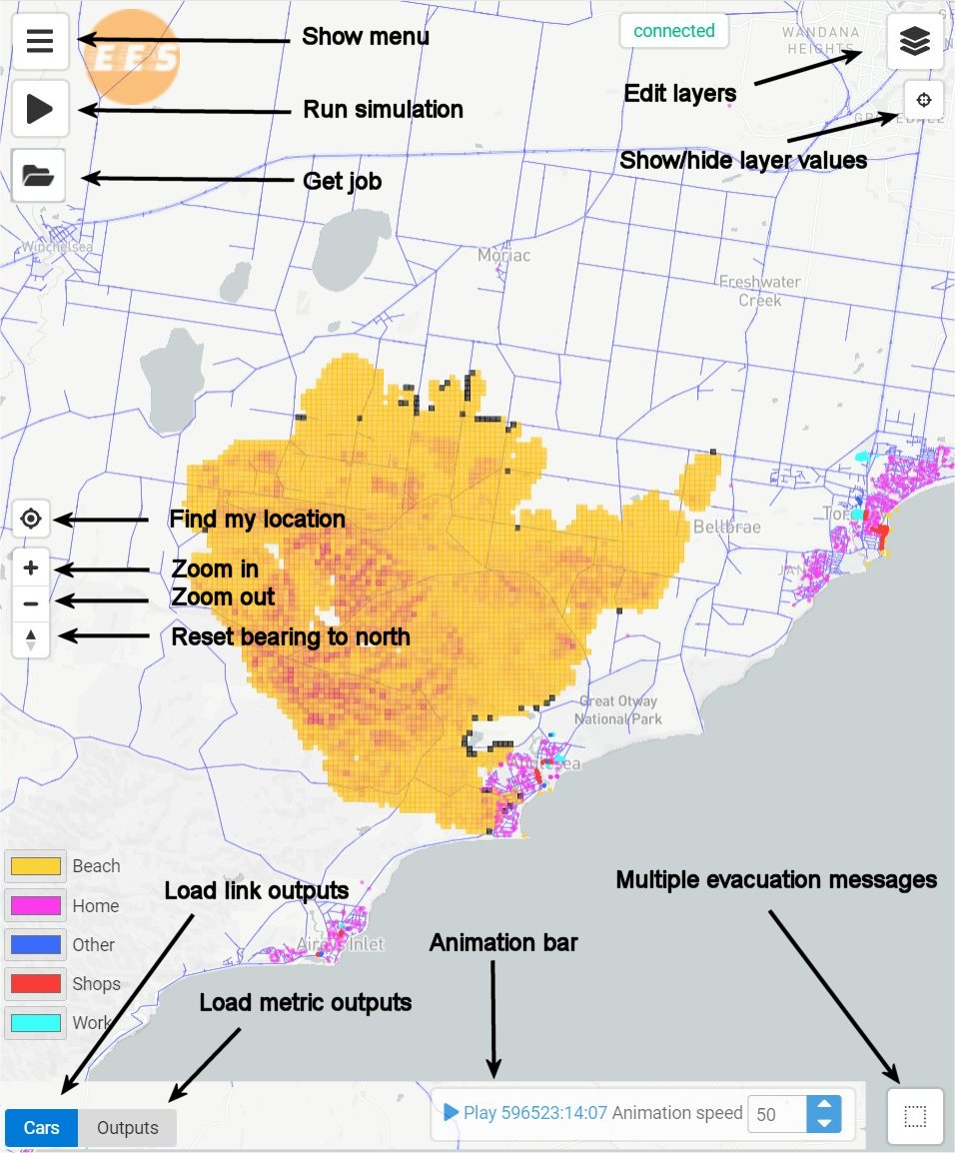

Figure . Location of viewer controls in Map Viewer

Table . Description of viewer controls in Map Viewer

|  |  |
| --- | --- |
| **Control** | **Description** |
|  | **Show menu** - This control, when clicked, opens the Main menu as shown in Figure 21. Please refer to **7 Appendix C: Menu** for a description of the options in the Main menu. |
|  | **Get job** - This control, when clicked, opens the **Load Job** dialog as shown in Figure 24. Please refer to **7 Appendix C: Menu** for a description of the controls in the **Load Job** dialog menu. |
|  | **Run simulation** - This control, when clicked, will initiate the simulation run for the currently loaded new job. A progress bar will be displayed in the Map Viewer while the simulation run is being completed. This control is only displayed when a loaded job has a pending simulation run. |
|  | **Find my location** - This control, when clicked, will mark the location of the user on the world map displayed in the Map Viewer. |
|  | **Zoom in** - This control, when clicked, allows the user to zoom in on the map display and increase magnification while maintaining the centre of the map. |
|  | **Zoom out** - This control, when clicked, allows the user to zoom out of the map display and decrease magnification while maintaining the centre of the map. |
|  | **Reset bearing to north** - This control, when selected, allows the user to change the angle of the displayed map. Click on this icon, and with the left button down, drag the mouse around the screen to rotate and tilt the map along the centre. Click on the icon and release to reset the angle to the original setting. |
|  | **Edit layers** - This control toggles on/off the display of the panel of map settings. If a new scenario has been defined, then this button will open the **Scenario Settings** panel as shown in Figure 27. Please refer to **8 Appendix D: Scenario Settings** for a description of the options and controls in the **Scenario Settings** panel. If a job has been loaded, then this button will open the Outputs panel as shown in Figure 30. Please refer to **10 Appendix G: Outputs Panel** for a description of the options and controls in the **Outputs** panel. |
|  | **Show/Hide layer values** - This button toggles on/off the display of metric information on an area or link just by passing the mouse over the point. Values on the current active metrics will be displayed on a bubble for the area or link pointed to by the mouse. |
|  | **Multiple Evacuation Messages** - This button enables zone selection mode and opens the **Evacuation Messages** dialog, shown in Figure 28, to specify the messages to be issued as part of the evacuation plan to the selected evacuation zones at the selected time. This button only appears when a new scenario is loaded. Please refer to **10 Appendix G: Outputs Panel** for a description of the options and controls in the **Evacuation Messages** dialog. |
|  | **Load link outputs** - This control, when clicked, allows the user load the link outputs and view the simulation of vehicle movement along a map of the road network. This controls appears only after a job file has been loaded. |
|  | **Load metric outputs** - This control, when clicked, allows the user to load the metric outputs and view thematic maps of values from the different metrics. This controls appears only after a job file has been loaded. |
|  | **Animation Bar** - This bar contains two controls. The Play (Pause) button, when clicked, starts (pauses) the display of the animation of traffic flow during the simulation. The time of the activity is displayed to the right of the button. The animation speed button allows the user to increase or decrease the speed of the animation. |

# Appendix C: Menus and Dialogs

WebDSS provides a series of menus and dialogs that guide the user in performing the various tasks associated with running a simulation model. This section presents the different menus and dialogs and describes the options and controls that are provided. The menus are opened by clicking the associated buttons in the Map Viewer. Please refer to **6 Appendix B: Viewer Controls** for a description of the controls in the Map Viewer.

## Main menu

The Main menu, shown in Figure 21, is the point of entry for doing any task in WebDSS. The Main menu is opened by clicking the **Show Menu** button in the Map Viewer. Table 2 provides a description of the options in the Main menu.



Figure . Main menu

Table . Options in the **Main** menu

|  |  |
| --- | --- |
| **Option** | **Description** |
| **Job** | This option, when selected, will open the **Job** menu, as shown Figure 22. |
| **View** | This option, when selected, will open the **Logs** menu, as shown in Figure 25. |
| **Logout** | This option, when selected, will log out the user from the WebDSS session |

## Job menu

The main activity in WebDSS is the running of a simulation job and the presentation of the simulation outputs. The Job menu, shown in Figure 22, allows the user to create a new job or load a previously saved job. Table 3 provides a description of the options in the Job menu.

A new job is created by assigning a unique name to the new job using the New Job dialog, as shown in Figure 23. Note that only alphanumeric characters are allowed in the job name.

A saved job is loaded by selecting the job from a list of saved jobs in the Load Job dialog, as shown in Figure 24. Table 4 provides a description of the controls in the Load Job dialog.



Figure . Job menu

Table . Options in the **Job** menu

|  |  |
| --- | --- |
| **Option** | **Description** |
| **New** | This option, when selected, will open the **New Job** dialog, as shown in Figure 23. |
| **Load** | This option, when selected, will open the **Load Job** dialog, as shown in Figure 24. |
| **Run** | This option, when selected, will run a simulation using the settings from the currently loaded job. If the job has a new scenario, then the simulation will be run for the new scenario. If the job has completed its simulation run, then this option will produce an error message. |
| **Back** | This option, when selected, will return the user to the **Main** menu |



Figure . New job dialog



Figure . Load Job dialog showing **myJob1**

Table . Controls in the Load Job dialog

|  |  |
| --- | --- |
| **Control** | **Description** |
|  | **Run simulation** - This control, when present, indicates that the corresponding job has a pending simulation run to be performed. Clicking on this icon will start the simulation run. |
|  | **Delete job** - This control, when present, allows the user to delete the job from the WebDSS server. |
|  | **Server connections** - This control displays the number of users connected to the WebDSS server who have loaded the corresponding job in their individual browsers. |
|  | **Load Job** - This control, when clicked, will load the highlighted job into the WebDSS Map Viewer replacing any job that is currently loaded. |
|  | **Cancel** - This control, when clicked, will close the Load Job dialog without performing any action. |

## Logs menu

WebDSS creates messages in response to commands issued from the menus and dialogs. All messages, including error messages, are saved in a **Log** file which can be viewed and referenced for debugging purposes and product improvement. The Logs menu, shown in Figure 25, provides the option for viewing the Log file. Table 5 provides a description of the options in the Logs menu.

Figure 26 shows a sample Logs window with the contents of the Log file displayed in the text box. Table 6 provides a description of the controls in the Logs window.



Figure . Logs menu

Table . Options in the **Logs** menu

|  |  |
| --- | --- |
| **Option** | **Description** |
| **Show Logs** | This option, when selected, will open the **Logs** window, as shown in Figure 26. The window displays the contents of the Log file of messages and errors produced by WebDSS during the modelling session. |
| **Enable/Disable Debug** | This option, when selected, will turn on/off the debug facility in WebDSS. |
| **Back** | This option, when selected, will return the user to the **Main** menu. |



Figure . Sample Logs window

Table . Controls in the Logs window

|  |  |
| --- | --- |
| **Control** | **Description** |
|  | **Close window** - This control, when clicked, will close the Logs window. |
|  | **Download Log file** - This control, when clicked, saves the Log file as a tab-delimited text file. The text file can then be sent to the WebDSS development team to improve itsWebDSS performance. |
|  | **Clear Log file** - This control, when clicked, will clear the Log file of all its contents. The Log window will also be cleared. |

# Appendix D: Scenario Settings

After a **New Job** has been created and loaded from the Jobs menu, the facility to define the settings for the new scenario is provided by the **Scenario Settings** panel as shown in Figure 27. The **Scenario Settings** panel is displayed by clicking on the **Edit Layers** button in the Map Viewer. Please refer to **6 Appendix B: Viewer Controls** for details on the **Edit Layers** button, the **Multiple Evacuation Messages** button and other controls in the Map Viewer.

|  |  |
| --- | --- |
| Figure . Scenario Settings panel | The contents of the **Scenario Settings** panel are described as follows:   * **Select a region** - This list box allows the user to select the region and road network to be used in the scenario. Only one region can be selected from the list. The selected region is highlighted using the controls described in Table 7. * **Fire** - This dropdown box allows the user to select the fire event file to be used in the scenario. * **Fire ignition time** - This edit box allows the user to enter the ignition time of the fire event used in the scenario. * **Population** - This dropdown box allows the user to select the population file to be used in the scenario. * **Time** - This graphic indicates the time associated with the fire coverage and distribution of population values displayed on the map. The time is set by using the **Time Slider.** The **Time Slider** is one of the controls described in Table 7. * **Show evacuation zones** – This control toggles on/off the display of the evacuation zones in the Map Viewer, so that the evacuation zones can be referenced in the evacuation plan. * **Evacuation plan** - This list box displays the evacuation messages issued and the time of issue as part of the evacuation plan. When a specific message in the list box is selected, the associated evacuation zones will be highlighted in the Map Viewer. The evacuation messages are set using the **Evacuation Messages** dialog, as shown in Figure 28. The description of the controls in the dialog is given in Table 8. * **Maximum speed on roads 60%** - This slider sets the XXXX. * **Map & Layers Settings** – This control will open the **Map & Layers Settings** panel**.** Please refer to **9 Appendix E: Map and Layer Settings** for detailed information on the controls and options in the **Map & Layers Settings** panel. |

Table . Additional Controls in the Scenario Settings panel

|  |  |
| --- | --- |
| **Control** | **Description** |
| / | **Show/Hide** - This control toggles on/off the display of the road network layer for the selected region. |
|  | **Move Highlight Up** - This control, when clicked, moves the highlight in the region list one item up. |
|  | **Move Highlight to Top** - This control, when clicked, moves the highlight in the region list to the top of the list. |
|  | **Move Highlight Down** - This control, when clicked, moves the highlight in the region list one item down. |
|  | **Move Highlight to Bottom** - This control, when clicked, moves the highlight in the region list to the bottom of the list. |
|  | **Time Slider** - This control, when clicked, allows the user to set the population time by dragging the slider left or right. The new population time is shown in the **Time** Display. As the **Time Slider** is moved left or right, the distribution of population values is updated on the map. |
|  | **Map & Layer Settings** - This button toggles on/off the display of the controls for the Map Layers. Please refer to **9 Appendix E: Map and Layer Settings** for more information on this panel. |



Figure . **Evacuation Messages** dialog

Table . Controls in the **Evacuation Messages** dialog

|  |  |
| --- | --- |
| **Control** | **Description** |
|  | **Messaged Zones** - This list box identifies the evacuation zones covered by the messaging. The evacuation zones are selected by:   1. Clicking on the **Multiple Evacuation Messages** button the first time to activate the zone selection mode; 2. Clicking on all zones to be included in the messaging; 3. Clicking on the **Multiple Evacuation Messages** button a second time to end the zone selection mode and open the **Evacuation Messages** dialog. |
|  | **Message Time** - This edit box specifies the time when the messaging is issued. The time can be entered or set using the up/down arrows in the edit box. |
|  | **Message Type** - This control allows the user to select the message from the list given in the dropdown box. The available messages are **ADVICE**, **WATCH&ACT**, **EMERGENCY_WARNING**, and **EVACUATE_NOW**. |
|  | **Comments** - This control allows the user to enter comments about the messaging. |
|  | **Add** - This control, when clicked, will save the messaging settings in the message data file . |
|  | **Close** - This control, when clicked, will close the **Evacuation Messages** dialog. |

# Appendix E: Map and Layer Settings

The controls for Map & Layer Settings appear as part of the options in the **Outputs** panel and the **Scenario** **Settings** panel.

|  |  |
| --- | --- |
| Figure . Panel for Map & Layer Settings | The contents of the **Map & Layer Settings** panel are described as follows:   * **Update on Zoom**  - This button, when activated, sets the thematic maps to update the colour scale each time the Map Viewer zooms in or out of regions. This means the colour scale is recalculated based on the associated maximum and minimum values in the current visible area. * **Opacity** - This control will set the ability to see through the layer, when the layer is visible, to view the layers underneath. The opacity value is set by moving the opacity slider to the left to make the layer more transparent or to the right to make the layer more opaque. * **Colour scale** - This control enables the user to select from 37 options the colour theme for mapping the values of the attribute specified in the **Colour by** option. Please refer to **9.1 Colour scales** for more information on the colouring options. * **Reversed** - This button toggles on/off the reversal of the **Colour scale** when applied to the values selected in **Colour by.** When toggled on (**Reversed**), the top colour in the **Colour scale** is applied to the minimum value and the bottom colour is applied to the maximum value in the value range. When toggled off (**x Reverse**), the top colour in the **Colour scale** is applied to the maximum value and the bottom colour is applied to the minimum value. * **Colour by** - This control enables the user to select the attribute or metric to be mapped using the selected **Colour scale**. Please refer to Table 12for the **Colour by** options available for the various output metrics. * **Min value** - This entry identifies the minimum value of the value range used in the thematic mapping of the metric or attribute selected in **Colour by**. * **Max value** - This entry identifies the maximum value of the value range used in the thematic mapping of the metric or attribute selected in **Colour by**. * **Map style** - This control enables the user to select from 5 options the background to be used in mapping the values of the attribute specified in the **Colour by** option. Please refer to **9.2 Map styles** for more information. |

## Colour scales

The **Colour scales** selection enable the thematic mapping of the values specified in the **Colour by** option. The top colour in the scale is mapped to areas or links with the **Max value** while the bottom colour is used for areas and links with the **Min value**. The colour used for the remaining areas or links is interpolated based on the associated value. This is the default or (**x Reverse**) option. If the **Reverse** toggle is activated, the top colour in the scale is then mapped to areas or links with the **Min value** while the bottom colour is used for areas and links with the **Max value**.

The 37 colour scales available are displayed in Table 9.

Table . Colour scale options as applied to Population in Zones values

|  |  |  |  |
| --- | --- | --- | --- |
| **interpolateBlues** | **interpolateCool** | **interpolateGreys** | **interpolateOranges** |
| **interpolateBrBG** | **interpolateCubehelixDefault** | **interpolateInferno** | **interpolatePRGn** |
| **interpolateBuGn** | **interpolateGnBu** | **interpolateMagma** | **interpolatePiYG** |
| **interpolateBuPu** | **interpolateGreens** | **interpolateOrRd** | **interpolatePlasma** |
| **interpolatePuBu** | **interpolatePuBuGn** | **interpolatePuOr** | **interpolatePuRd** |
| **interpolatePurples** | **interpolateRainbow** | **interpolateRdBu** | **interpolateRdGy** |
| **interpolateRdPu** | **interpolateRdYlBu** | **interpolateRdYlGn** | **interpolateReds** |
| **interpolateSinebow** | **interpolateSpectral** | **interpolateTurbo** | **interpolateViridis** |
| **interpolateWarm** | **interpolateYlGn** | **interpolateYlGnBu** | **interpolateYlOrBr** |
| **interpolateYlOrRd** |  | | |

## Map styles

The map style options available in the **Map & Layer Settings** panel are described in Table 10.

| Table . Map style options | |
| --- | --- |
| **Map Display** | **Map Style Description** |
|  | **Light** - This option, when selected, allows the user to set a light-coloured background for the maps displayed in the Map Viewer.  More Info - [Mapbox Light](https://www.mapbox.com/maps/light) |
|  | **Dark** - This option, when selected, allows the user to set a dark-coloured background for the maps displayed in the Map Viewer.  More Info - [Mapbox Dark](https://www.mapbox.com/maps/dark) |
|  | **Streets** - This option, when selected, allows the user to set a background which mainly focus on road and transit network. Transit layers (Motorways, footpaths) are coloured based on the mode of transit.  More Info - [Mapbox Streets](https://www.mapbox.com/maps/streets) |

|  |  |
| --- | --- |
|  | **Satellite** - This option, when selected, allows the user to set a background using satellite imagery for the maps displayed in the Map Viewer.  More Info - [Mapbox Imagery](https://www.mapbox.com/maps/satellite) |
|  | **Outdoors** - This option, when selected, allows the user to set a background which emphasizes outdoor features such as hiking and biking paths.  More Info - [Mapbox Outdoors](https://www.mapbox.com/maps/outdoors) |

XX

# Appendix G: Outputs Panel

The results of the evacuation simulation are stored in terms of a number of performance measures or metrics. The set of metrics used by WebDSS are described in **11 Appendix F: Output Metrics**. The values of the metrics over the duration of the simulation period are recorded for each evacuation area or transport link. These metrics can then be loaded and visualised as thematic maps and charts in the Map Viewer. The set of controls used to manage the selection and display of the metrics are presented in the **Outputs** panel, as shown in Figure 30.

|  |  |
| --- | --- |
| Figure . Controls in the Outputs panel | The contents of the **Outputs** panel are described as follows:   * **Select a metric** - This list box allows the user to select the metrics to be displayed in the Map Viewer. One or more metrics can be selected. The selected metric is displayed by enabling the **Show/Hide** button described in Table 11. * **Time** - This graphic indicates the simulation time when the output values displayed in the map layers occur. The simulation time is set by using the controls **Move Time Backward, Move Time Forward,** or the **Time Slider,** as described inTable 11**.** * **Map & Layers Settings** – This control will open the **Map & Layers Settings** panel**.** Please refer to **9 Appendix E: Map and Layer Settings** for detailed information on the controls and options for **Map & Layers Settings.**   The rest of the controls in the **Outputs** panel are described in Table 11. |

Table . Description of Controls in the Outputs panel

|  |  |
| --- | --- |
| **Control** | **Description** |
| / | **Show/Hide** - This control toggles on/off the display of the map layer for the corresponding output metric. |
|  | **Move Visibility Up** - This control, when clicked, moves the highlighted metric one item up in the visibility hierarchy. This means that the metric layer will be displayed on top of all the other displayed metric layers below it. |
|  | **Move Visibility to Top** - This control, when clicked, moves the highlighted metric to the top of the visibility hierarchy. This means that the metric layer will be displayed on top of all the other displayed metric layers. |
|  | **Move Visibility Down** - This control, when clicked, moves the highlighted metric one item down in the visibility hierarchy. This means that the metric layer will be displayed on top of all the other displayed metric layers below it. |
|  | **Move Visibility to Bottom** - This control, when clicked, moves the highlighted metric to the bottom of the visibility hierarchy. This means that the metric layer will be displayed below all of the other displayed metric layers. |
|  | **Simulation Information** - This control, when clicked , opens a window where a summary of the simulation settings are displayed, as shown in Figure 31. |
|  | **Move Time Backward** - This control, when clicked, moves the selected simulation time backward by 1 hour. The new simulation time is shown in the **Simulation Time** **Display**. |
|  | **Move Time Forward** - This control, when clicked, moves the selected simulation time forward by 1 hour. The new simulation time is shown in the **Simulation Time** **Display**. |
|  | **Time Slider** - This control, when clicked, allows the user to set the simulation time by dragging the slider left or right. The new simulation time is shown in the **Simulation Time** **Display**. |
|  | **Download image** - This control, when selected, allows the user to capture an image of the currently displayed screen in the Map Viewer, and then open or save the image as a file in PNG format. If the user chooses to save the image, a dialog will be displayed asking for the destination directory and file name. |
|  | **Download** - This control, when selected, allows the user to view the values of the selected metric for the entire simulation period or save the values in a file in JSON format. If the user chooses to save the data file, a dialog will be displayed asking for the destination directory and file name. (Need to call this Download JSON) |
|  | **Download CSV** - This control, when selected, allows the user to view the values of the selected metric for the entire simulation period or save the values in a file in CSV format. If the user chooses to save the data file, a dialog will be displayed asking for the destination directory and file name. (Need to add CSV in filename) |
|  | **Show chart** - This control, when selected, opens a window containing a chart of the values for the selected metric plotted against time. If no specific area is selected, the chart will show the values for all evacuation areas. If a specific area is selected by clicking the area with the mouse, only the values associated with the selected area will be displayed in the chart. |
|  | **Map & Layer Settings** - This button toggles on/off the display of the controls for the Map Layers. Please refer to **9 Appendix E: Map and Layer Settings** for more information on this section. |



Figure . Simulation Information window

# Appendix F: Output Metrics

The output from the simulation run includes a number of metrics used to measure and illustrate various characteristics of the evacuation over time including the areas affected and amount of damage inflicted by the fire hazard, the number of people remaining in zones and links, and the risk of house loss. Table 12 describes the different metrics used and provides samples of the visualization in the map display.

Table . Output metrics and **Colour by** options

|  |  |
| --- | --- |
| **Map Display** | **Metric Description** |
|  | **Area Burnt** - This metric denotes the amount of damage sustained by a 1KmX1Km grid from the fire event over time.  **Colour by** options include:   * **Burnt Percentage** – Percentage of the area in the grid that is affected by fire at any given time |
|  | **Affected Network** - This metric denotes the transport links that are affected by the fire event. A transport link is affected if the fire intersects with the link at any time.  **Colour by** options include:   * **Affected Time** – Time when the fire front intersects with the transport link * **Population** – Number of cars on the transport link XXXX |
|  | **Affected Zones** - This metric denotes the evacuation areas that are affected by the fire event. An area is affected if the fire intersects with the area at any time  **Colour by** options include:   * **Affected Time** – Time when the fire front intersects with the evacuation area * **Population** – Number of people in the zone at the time when fire enters the zone |
|  | **Emergency Messages** – This metric denotes the emergency messages issued over the evacuation areas over time.  **Colour by** options include:   * **Type** – Text of message issued |
|  | **House Loss Risk Labels / House Loss Risk Zones** - This metric evaluates the probability of house loss in the area due to the fire event  **Colour by** options include:   * **Risk** – Rating (SEVERE, EXTREME, HIGH, MODERATE, LOW) commensurate to the probability of house loss in the area |
|  | **Population in Zones** - This metric denotes the number of people in the evacuation area at any given time  **Colour by** options include:   * **Total Agents** – Total number of individuals in the zone * **Agents in Activities** – Number of people outside of cars in the zone * **Agents Driving** – Number of people inside cars that are in the zone |
|  | **Network Traffic** - This metric denotes the number of people in transport links at any given time  **Colour by** options include:   * **Total Agents** – Total number of individuals in the transport link * **Agents in Activities** – Number of people outside of cars in the transport links * **Agents Driving** – Number of people inside cars that are in the transport links |
|  | **Population in Grids** - This metric denotes the number of people in transport links inside the 1KmX1Km grids at any given time  **Colour by** options include:   * **Total Agents** – Total number of individuals in the 1KmX1Km grids * **Agents in Activities** – Number of people outside of cars in the 1KmX1Km grids * **Agents Driving** – Number of people inside cars that are in the 1KmX1Km grids |
|  | **Fire Intensity** - This metric XXXX XXXX XXXX XXXX XXXX XXXXX XXX XXXXX XXXX XXXXXXXXX XXXXXXXX XXXXXX XXXXXX XXXXXX XXXXX XX.  **Colour by** options include:   * **Fire Intensity** – to be discussed |

XXXXX

|  |  |  |
| --- | --- | --- |
| At CSIRO we shape the future  We do this by using science and technology to solve real issues. Our research makes a difference to industry, people and the planet. |  | w www.data61.csiro.au |